Student Name: Xianglong Lin Student Number: 45791439 Team Name: H2OMG
Week: _12_
Title: Final Front-End Interface and Data Encryption Implementation in the Water Resource Protection System
Description:
In the studio in the 12th week near the end of the course, I completed the last part of my front-end dynamic interface - the setting page, which allows users to turn on and off notifications and alerts and view related privacy policy and about details. Meanwhile, based on the data security consideration I proposed last week, I implemented the AES-256 encryption algorithm in the JS code to encrypt the water flow data transmitted by the water flow sensor and store it in a local file.
Specifically, I used the crypto library in Node.js to generate a random encryption key and initialisation vector (IV) before saving the encrypted water flow data to a file. Furthermore, I added appropriate English comments to all the code and took the initiative to write a README document so that the mentor could understand our project's working principle and encryption process more quickly and better in Exhibit 2.
Visual Evidence:
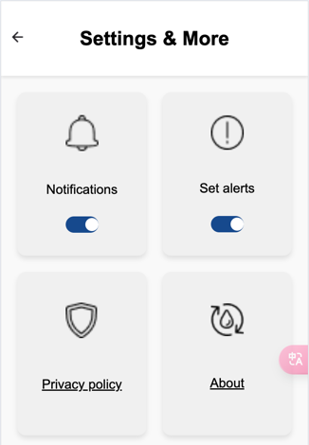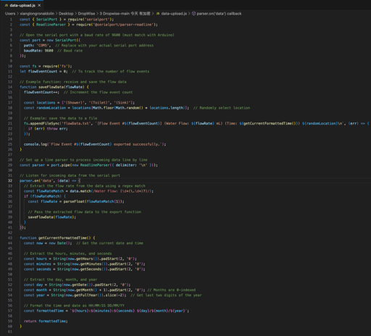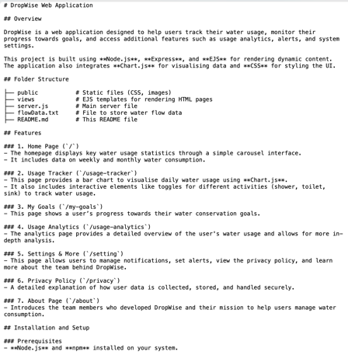
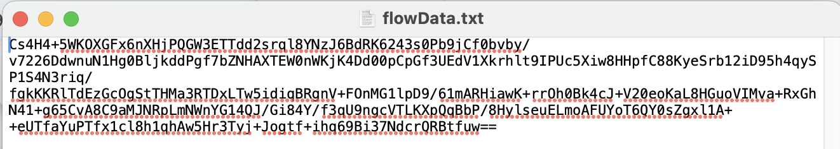
Statement on Learning:
This week's studio not only enabled me to further enhance the security of the project by implementing data encryption, but also ensured the overall security of the system and the privacy protection of user data. I taught myself how to encrypt sensor data using the AES-256 algorithm, and I recognised the critical role of data encryption in preventing data leakage.
On the other hand, the writing of code comments and README documents has made me realise the importance of code readability and documentation for team collaboration and project presentation. Documentation not only helps team members better understand how the system works, but also makes it easier for mentors to mark and provide feedback in Exhibit 2.
Through systematic learning of DECO2850, I have deeply strengthened my multi-faceted skills required for developing secure, effective, and scalable systems, including but not limited to programming, data encryption, security considerations, and documentation work. This will also become my immediate strength in employment after near graduation.

